ICAK-BALTICUM – Call for papers
PLEASE FILL OUT THE FORM AND SEND WITH APPROPRIATE ABSTRACT

Complete name and degree:
Mailing address:
E-mail address:
Web site (if appropriate):
I propose the following presentation (title):

Please send us an abstract of your presentation (minimum 4 lines, maximum 15)

Printed presentations should be submitted in the format outlined by the IBE:
http://www.ibe-icak.org/download/requirements.pdf and
http://www.ibe-icak.org/download/autorenrichtlinien.pdf

Please send us your recent facial photo.

Lecturers are required to submit presentations in a printable format for publication in the Conference- Proceedings.
PowerPoint or PowerPoint compatible presentation is required.
Lecturers must, by signing the form below, attest that all intellectual material is original and that any intellectual material from other sources is noted as required by international copy write law.

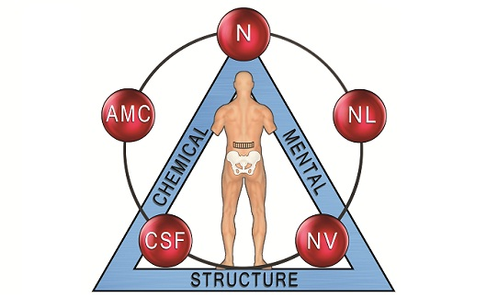
Your signature:



